Adapted from http://www.biologycorner.com/worksheets/interpreting_data.html
INTERPRETING ECOLOGICAL DATA
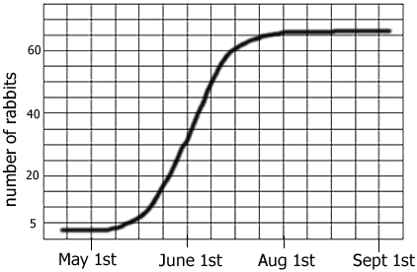
Graph 1: Rabbits Over Time
a. The graph on the right shows that the rabbit population has increased or decreased?
b. The carrying capacity (you have to figure out what this term means) for rabbits is ______
c. During which month were the rabbits in exponential (very fast) growth?

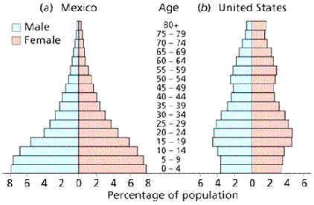
Graph 2: Mexico and US
a. In Mexico, what percentage of the population is between 0-4 years of age? _______ In the US? ______
b. Which age group has the smallest percentage in both countries? _____
c. Which country is likely to have the fastest growing population? Provide a reason for your answer (using the graphs as evidence)

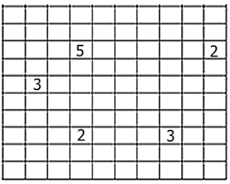
Chart 3: Mushroom Plots
An ecologist uses a sampling method to estimate the number of mushrooms in a forest.
- Firstly she sets out a 10 metre x 10 metre grid (100 square metres)
- Secondly she randomly chooses 5 single square metre spots of the grid, where
- Thirdly she counts the number of mushrooms in the plots
Her results are shown on the diagram of the grid on the right
- What is the total number of mushrooms she counted in the 5 different spots?

- What is the average (mean) number of mushrooms for each square metre of the grid?

- How many mushroom would you expect to be in the entire 10m by 10m grid? (Show your calculation)

- If the forest actually covered 120 hectares (1 hectare is 10,000 square metres), how many mushroom would you expect to find in the whole forest? (show your calculations)

- Do you expect your answer to D to be a good estimate of the number of mushrooms in the forest? Justify (explain why) your answer.

